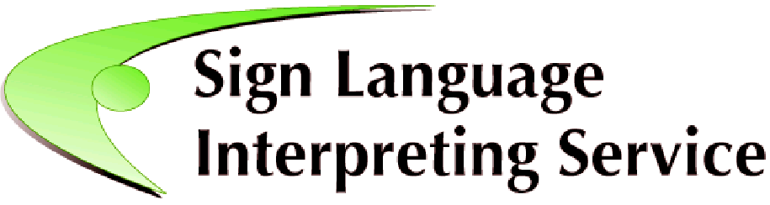
SLIS Administrator (Full-time, Temporary Contract)
Job Description
background
The Sign Language Interpreting Service (SLIS) is an independent body, funded and supported by the Citizens Information Board (CIB), to develop, promote and deliver quality sign language interpreting services to the Deaf community in Ireland, including face to face and remote services. SLIS is working to enhance the availability and quality of sign language interpreting in Ireland in response to the National Human Rights Strategy for Disabled People 2025-2030 and the Irish Sign Language Act 2017.

Nature and scope
The SLIS Administrator provides administrative support to SLIS services including the referral service, Social Inclusion Voucher scheme, hardship / social fund, emergency services, access support service and IRIS (Irish Remote Interpreting Service), as well as general organisational administration.
main responsibilities
Administration
- Deal appropriately with all relevant telephone, letter and personal enquiries.
- Assist in the production of documents and materials.
- Maintain an efficient records management system and assist in the preparation of administration and management reports.
- Maintain the office in relation to office supplies, upkeep of equipment, and maintenance of premises.
- Organise meetings, arranging the venues and necessary facilities, informing participants and taking minutes of meetings as required.
- Be aware, and on occasion, co-ordinate the diaries of team members as required.

Booking Voucher and Referral System
- Manage the day-to-day operation of the booking and referral system by ensuring the database of interpreters and service users is maintained and interpreters have been correctly allocated to each assignment.
- Respond in a timely and accurate manner to all booking and referral enquiries.
- Administer Service Level Agreements with interpreters, as appropriate.
- Support Deaf citizens to get appropriate access to the services through the provision of sign language interpreting.
- Provide information to service providers on good practice for organising sign language interpreting services.
- Liaise with interpreters and service users.
- Liaise with external technical support in relation to the development of the SLIS website and Booking System.

General
- Participate in Performance Management Development System (PMDS)
- Attend agreed training and development courses to maintain and improve performance including Irish Sign Language, if required.
- Provide administrative & other supports to the work undertaken by SLIS (including GDPR and financial compliance), and its working groups as required.
- Undertake such other duties as may be agreed from time to time with the Manager, SLIS.

Terms of Employment
Reports to
The SLIS Manager.

Location
Your place of work will be SLIS, Deaf Village Ireland, Cabra, Dublin 7, Ireland.

Hours
Hours of work are 35 hours per week.
Flexible working hours may be required on occasion. Time off in lieu may be accumulated with prior agreement with the Manager.

Salary
Salary Scale of €31,739, €33,047, €34,352, €35,654, €36,954, €38,263, €39,565, €40,873, €43,340 (max) - €45,089 (LSI1) - €46,841 (LSI2). Salaries calculated on a pro-rata basis for part-time staff.
*LSI = Long service increment achieved after 3 years’ service
Incremental Credit:
It is expected that all new entrants to SLIS will be appointed at point one of the salary scale however the Sign Language Interpreter Service operates an incremental credit process for appointments higher than point one. This process is applicable to new entrants into SLIS. Incremental credit criteria, based on the competencies for the role, are assessed against employment history as laid out in the application form only. A request for incremental credit from a successful candidate must be made within the first 3 months of employment. The decision on whether or not to award an incremental credit is a decision made by the Board and is subject to the availability of funding.
Annual Leave
This post equates to 23 days per year (pro-rata for part-time staff), exclusive of public holidays.

Pension:
A company pension scheme is in place, and membership is obligatory upon commencement. Employee contribution; 5% of salary, Employer contribution; 7% of salary. Please note that SLIS has established a normal retirement age in line with the State Pension (currently 66).

Person Specification

Essential
- Hold a recognised qualification at Leaving Certificate level or a minimum of Level 5 on the National Framework of Qualifications
- Experience of up to 1 year working in an administration role.
- Excellent organisational and record keeping skills, with strong attention to detail.
- Good IT abilities, including Microsoft Outlook, Word, Excel, Teams.
- Self-starter with ability to work on own initiative and manage own workload effectively.
- Competency in Irish Sign Language and is open to improving ISL competency.

Desirable
- Knowledge or experience working with the Deaf community.
- Skills or experience working with IT programmes.
- Additional promotional, financial or other administrative experience.
- Hold a recognised qualification at a minimum of Level 6 on the National Framework of Qualifications.

SLIS Administrator – Required Competencies

Competency | Indicators
C1  Planning, Organising & Administration | - Organises own time effectively, creates own work schedules, prioritises workload, prepares in advance and sets realistic timescales.  - Uses relevant systems to organise and prioritise workload effectively and diary manage their own and others work.  - Makes sure activity and resources are used efficiently and effectively  - Is flexible and is adaptable to changing circumstances  - Ability to successfully plan and organise meetings or events in a busy working environment, prepare documentation and take minutes of same.  - Follows procedures and protocols, understanding their value and the rationale behind them.
C2  Quality Client Service | - Consistently strives to perform at a high level and deliver a quality service.  - Experience in dealing with clients in a helpful and professional manner, displaying empathy, diplomacy and tact.  - Excellent reception skills both in person, over the phone or online and understands the steps or processes that clients must go through and can clearly explain these.  - Is respectful, courteous and professional, remaining composed, even in challenging circumstances.  - Observes strict client confidentiality and is dedicated to providing a quality service to both internal and external clients.
C3  Effective Communication | - Ability to effectively communicate, both verbally and in writing, with individuals and groups.  - Actively listens to others and tries to understand their perspectives/ requirements/ needs.  - Ability to engage with people from diverse backgrounds, demonstrating sensitivity to their issues.  - Builds and maintains good working relationships with colleagues and other external stakeholders.  - Competency in Irish Sign Language and is open to improving ISL competency.
C4  Teamwork & Collaboration | - Ability to work co-operatively within a group and to achieve goals in a respectful manner  - Understands and is tolerant of differing needs and viewpoints  - Works well with all stakeholders, both internal and external  - Actively helps and supports others to achieve team goals
C5  Record Management | - Produces high quality work showing accuracy and attention to detail  - Displays familiarity with the main systems and procedures related to the administrative work of the company.  - Ability to use data collection and/or statistical analysis systems efficiently, inputting data and compiling reports.  - Works confidently with figures.  - Uses databases and systems to maximise record management

Competency | Indicators
C6  Specialist Knowledge, Expertise & Self Development | - Good working knowledge of Microsoft Office applications, spreadsheets, and online communication.  - Develops and maintains the skills and expertise required to perform the role effectively e.g. relevant technologies and policies.  - Is committed to self-development and continuously seeks to improve personal performance.

