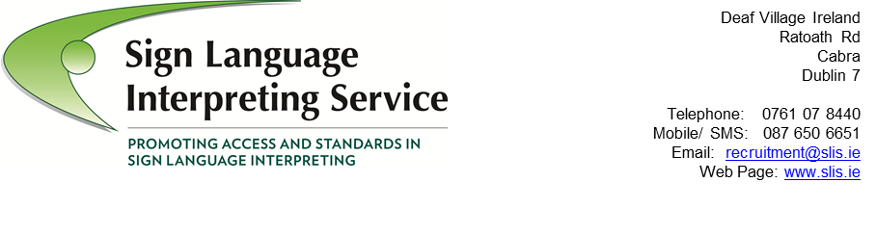
APPLICATION FORM

Entries on this form should be typewritten, if possible, or BLOCK PRINTED in black ink.

Post applied for: Irish Sign Language / English Interpreters in SLIS

DEADLINE FOR APPLICATIONS – 5pm on Thursday 6th June 2024

Full Name: …………………………………………………………………………………………………………………..

Home Address ……………………………………………………………………………........……………………...

…………………………………………………………………………………………………………………….................

…………………………….………………………………………Tel No.: …………………………….……………………

Email address: …………….………………………………….…………………………………………………………..

Current Work Tel No.: …………………………………….…………………………………………………………..
May we contact you at work (with discretion)? Yes/No

Present Position & Main Duties and Responsibilities:

…………………………………………………………………………………………………………………….................
…………………………………………………………………………………………………………………….................
…………………………………………………………………………………………………………………….................
…………………………………………………………………………………………………………………….................
…………………………………………………………………………………………………………………….................
…………………………………………………………………………………………………………………….................
…………………………………………………………………………………………………………………….................
…………………………………………………………………………………………………………………….................

Education History
Second & Third Level
School or College  Attended | Qualification  Obtained | Comments

Professional & Technical Training
Place of Training | Qualification Obtained | Comments
Registration Details if any
Date of Registration | Name of Body or Association | Registration Number

Employment History to Date (starting with most recent employer)

Dates  From To | Employers  Address | Post held & main duties undertaken | Salary & reason for leaving

Employment History to Date (continued)
Please add additional sheet(s) as necessary

Dates  From To | Employers  Address | Post held & main duties undertaken | Salary & reason for leaving
Please add additional sheet(s) as necessary
Voluntary Work/Student Placements to Date

Dates  From To | Name of Organisation | Main duties and  Responsibilities | Reason for  Leaving

Short Courses, Training Days Undertaken in the past three years to maintain or develop skills

Date of course | Facilitating group | Content of course | Benefit to you

Reason for Application
Please tell us clearly, paying particular attention to the essential and desirable criteria in the Advert and Job Description, why you feel you are appropriate for the post in question. If you wish to continue on additional paper, please do so.

……………………………………………….…………………………………………………………………………………...
……………………………………………….…………………………………………………………………………………...
……………………………………………….…………………………………………………………………………………...
……………………………………………….…………………………………………………………………………………...
……………………………………………….…………………………………………………………………………………...
……………………………………………….…………………………………………………………………………………...
……………………………………………….…………………………………………………………………………………...
……………………………………………….…………………………………………………………………………………...
……………………………………………….…………………………………………………………………………………...
……………………………………………….…………………………………………………………………………………...
……………………………………………….…………………………………………………………………………………...
……………………………………………….…………………………………………………………………………………...
……………………………………………….…………………………………………………………………………………...
……………………………………………….…………………………………………………………………………………...
……………………………………………….…………………………………………………………………………………...
……………………………………………….…………………………………………………………………………………...
……………………………………………….…………………………………………………………………………………...
……………………………………………….…………………………………………………………………………………...
……………………………………………….…………………………………………………………………………………...
……………………………………………….…………………………………………………………………………………...
……………………………………………….…………………………………………………………………………………...
……………………………………………….…………………………………………………………………………………...
……………………………………………….…………………………………………………………………………………...
……………………………………………….…………………………………………………………………………………...

Referees:
Please give the name, address and occupation of two referees to whom you are well known but not related, one of whom should be your most recent employer.

1. ……………..…….……..…...………….…………… 2. ……….....….…..…………..……………………….
……………..…….……..…...………….…………… ……………..…….……..…...………….……………
……………..…….……..…...………….…………… ……………..…….……..…...………….……………
……………..…….……..…...………….…………… ……………..…….……..…...………….……………

Occupation ……………..…….……..…...……… Occupation ……………..…….……..…...………

Relationship ……………..…….……..…...……… Relationship ……………..…….……..…...………
to You to You
Tel: ……………..…….……..…...………….……… Tel: ……………..…….……..…...………….………

References will be requested for successful candidates.
Do you require notification before your referees are contacted? Yes / No
The holder of this post will be subject to satisfactory Garda Vetting procedures.

Notice required by present employer: ……………..…….……..…...………….…………………………

Any other relevant information: ……………..…….……..…...………….……………………………………
……………………………………………….…………………………………………………………………………………...
……………………………………………….…………………………………………………………………………………...
……………………………………………….…………………………………………………………………………………...
……………………………………………….…………………………………………………………………………………...

Where did you see this post advertised: ……………………………………………………………………...

I certify that the information I have given on this application form is accurate to the best of my knowledge and belief. I agree if successful to undergo Garda Vetting procedures

Signed …………………………………………… Date …………………………

Please note short-listing may apply. A panel of interpreters may also be created to fill full and part time vacancies for a two year period.

PLEASE RETURN TO:
John Stewart, Manager, SLIS, Deaf Village Ireland, Ratoath Rd, Cabra, Dublin 7
Or by email to john.stewart@slis.ie
DEADLINE FOR APPLICATIONS – 5pm on Thursday 6th June 2024
For details on how your personal data will be used as part of this process our Data
Protection Notice for job applicants is available at:
http://www.citizensinformationboard.ie/en/data_protection/slis.html

Sign Language Interpreting Service is an equal opportunities employer.
Funded and supported by the Citizens Information Board.

