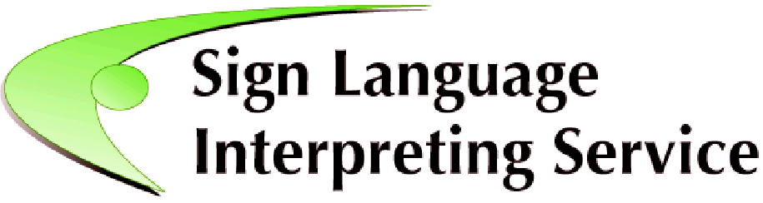
Development and delivery of a training programme for Deaf Irish Sign Language interpreters

Request for Tenders

Sign Language Interpreting Service (SLIS) was established in 2007, through the Citizens Information Board (CIB), and has the mission to promote, advocate and ensure the availability of quality sign language interpretation services.
With the passing of the Irish Sign Language (ISL) Act 2017, national policy now recognises that the lack of sign language interpreters is creating systematic barriers to the provision of inclusive and equitable public and other services for Ireland’s Deaf community.
The National Disability Inclusion Strategy (NDIS) 2017-2021 tasks SLIS to put in place a quality assurance and registration scheme for sign language interpreters and to provide on-going professional training and development for interpreters.
To advance this work, SLIS is now seeking tender submissions for the development and delivery of a training programme or stand-alone modules for Deaf sign language interpreters, expected to be equivalent to Level 7 or higher on National Framework of Qualifications Ireland.
This Request for Tender is a revision with small but significant changes to the tender previously issued on 24th October 2019.

Queries concerning this tender should be emailed to john.stewart@slis.ie before 2 pm on Wednesday 15 January 2020, and CC to register@slis.ie
If you would like to receive notification of clarification questions and answers, please register your interest by emailing john.stewart@slis.ie before the 15 January 2020.

- Closing date for receipt of tenders is 4 pm on 22 January 2020.
Tenders should be emailed to John Stewart (john.stewart@slis.ie) and CC to register@slis.ie

Please see Tender document attached below for detail.

