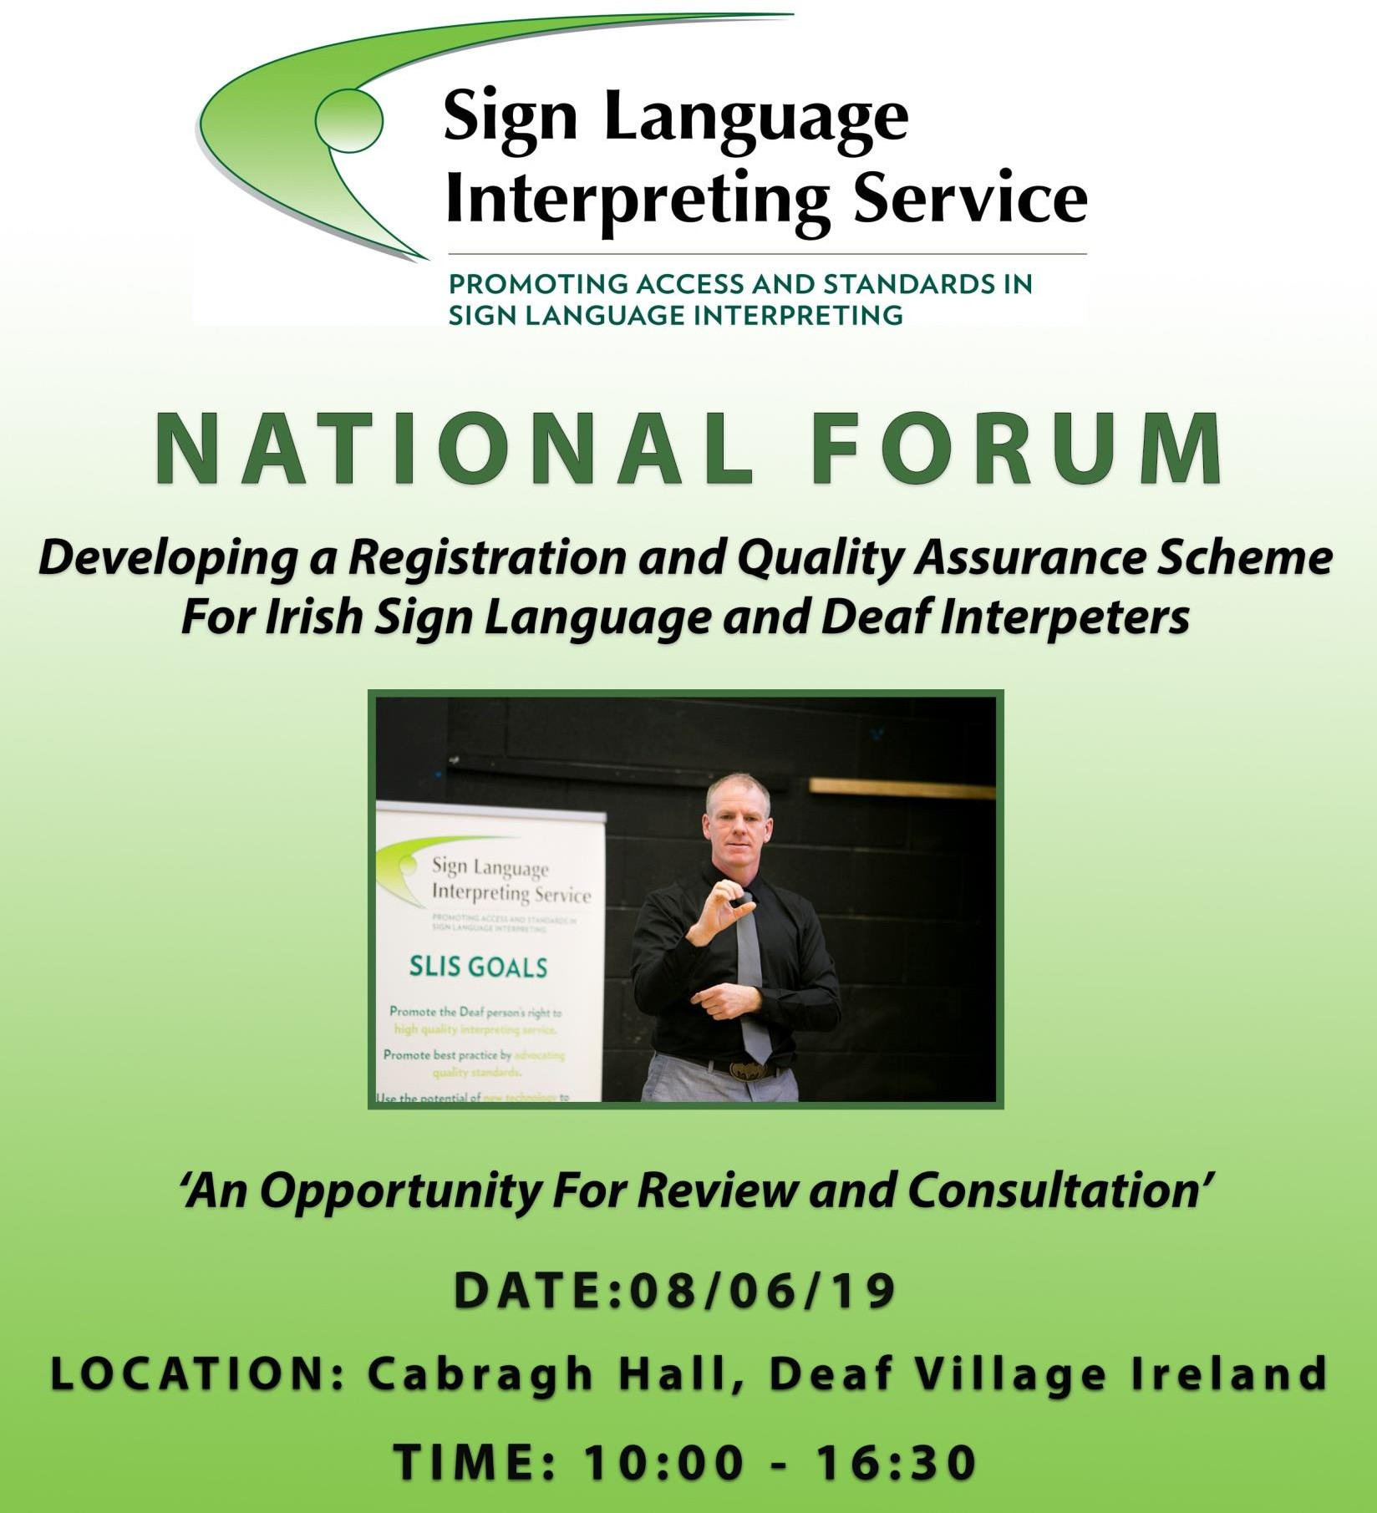
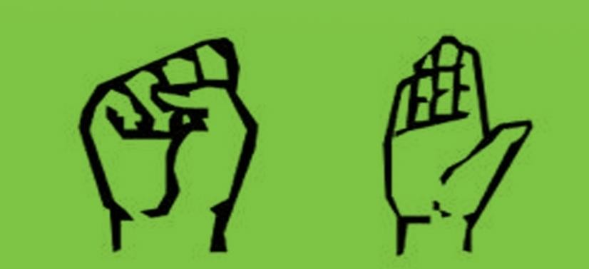
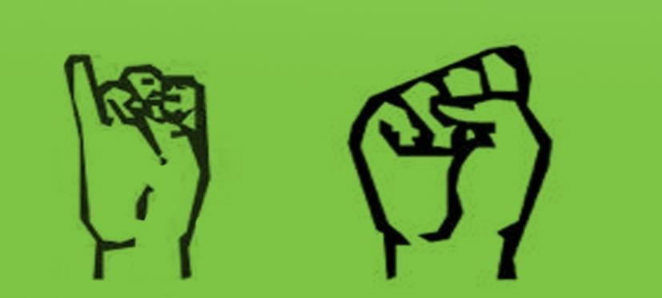

Sign Language Interpreting Service (SLIS) is developing a registration and quality assurance scheme for Irish Sign Language and Deaf interpreters in Ireland. The Irish Government, through the National Disability Inclusion Strategy (NDIS) 2017- 2021, has committed to “resource SLIS to increase the number of trained Sign
Language and Deaf Interpreters, to put a quality-assurance
and registration scheme for Interpreters in place, and to provide on-going professional training and development for
Interpreters” (NDIS page 17).

The Irish Sign Language Act 2017 obliges courts and public bodies to only engage the services of an Irish Sign Language (ISL) interpreter if their competence has been verified in accordance with the accreditation scheme (ISL Act 2017, section 7).

SLIS has been working with stakeholders (Deaf community, interpreters and others) to develop an outline of a registration and quality assurance scheme. The National Forum is an open consultation on development of the register.

THE AGENDA

10 AM Registration
Tea & Coffee will be available at the HUB in Deaf Village Ireland.
Attendees will be given packs at registration which will include the consultation papers Consultation Papers :
- Registration Scheme Process
- Complaints & Mediation
- The Code of Conduct
10:30 AM Opening
Chair of the morning session: Angela Black
- CEO of Citizens Information Board

Welcome: Anne Coogan
- Chairperson of SLIS
10:45 AM – 12:45 PM Morning Session
[10.45am] The Registration Process: Margaret O’Connor
- Quality Development Officer, SLIS
[11.15am] Service user perspective on the register - Need, Value, Benefits & Limitations:
Teresa Lynch
- Assistant Professor at the Centre for Deaf Studies
- Chairperson of the National Deaf Women of Ireland
- Deaf interpreter, Member of the Working Groups on Registration and Deaf Interpreting)
[11.30am] How the register will impact the interpreting profession: Suzanne Carey
- Irish Sign Language Interpreter
- Member of Sign Language Interpreters Munster (SLIM)
- Member of the Working Group on Registration
[11.45am] Lessons learned from the Dutch Sign Language Register: Benny Elferink
- Director of the Dutch Register for Sign Language and Speech-to-Text interpreters Foundation (RTGS),
- Project Co-ordinator of the Dutch Centre of Sign Language and former Chairperson of the Dutch National Deaf Association).
[12.15pm] Questions & Answers
[12.40pm] Wrap Up: Chair of the Morning Session, Angela Black
- CEO of Citizens Information Board

12:45 PM Lunch
Available at the HUB
2:00 PM – 3:30 PM Breakout Groups
- Consultation Rooms: Rathmines Room, Cabragh Hall and the SLIS Board Room

- Note takers and facilitators will be provided to each group

- Consultation sessions will cover the topics:
Registration Scheme Process, Complaints & Mediation, and The Code of Conduct
3:45 PM – 4:30 PM Afternoon Session
Chair for afternoon session: John Stewart
- National Manager, SLIS
  - pm: Facilitators sum up 4.15pm: Questions & Answers 4.25pm: Closing: Anne Coogan
    - Chairperson, SLIS

*Registered Attendees will also be sent Consultation Papers By Email In Advance*

Irish Sign Language Interpreters will be provided.
The event will be live streamed on the Facebook page „Slis Ireland‟.
For more information or to provide feedback on the
registration scheme, contact:
Quality Development Officer, Sign Language Interpreting Service, Deaf Village Ireland, Ratoath Road, Cabra, Dublin 7
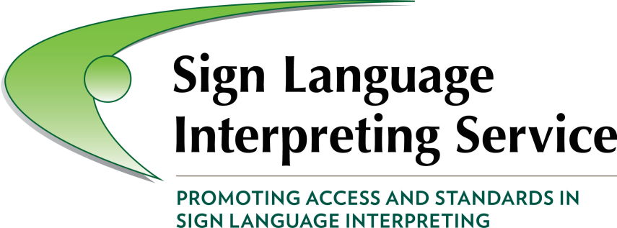
Ph: 0761 07 8440 SMS: 087 980 6996 Email: register@slis.ie Skype username: slis.remote1

Funded & Supported By:
