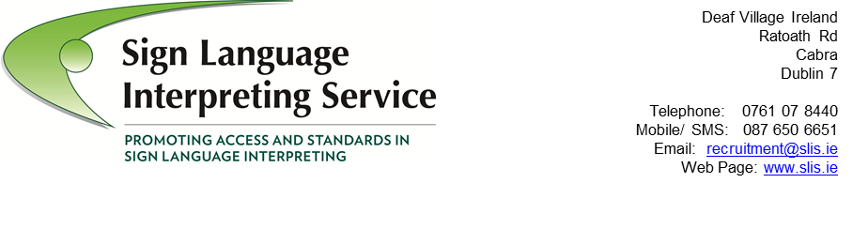
Sign Language Interpreting Service
In-house ISL/English Interpreter

Job Description

background

The Sign Language Interpreting Service (SLIS) is an independent body established by Citizens Information Board (CIB) to develop, promote and deliver quality sign language interpreting services to the Deaf community in Ireland, including face to face and remote services.

Nature and scope

The English / Irish Sign Language (ISL) Interpreter provides interpretive support primarily for the Irish Remote Interpreting Service but also to the Manager, SLIS Board and team, acting as the in-house interpreter for meetings where required.

main responsibilities

Scope
- To adhere to the SLIS code of conduct for Interpreters and fulfil SLIS’ expectations in terms of acting in an appropriate professional manner, promoting best practice, maintaining positive working relations with external agencies and respecting the confidentiality of any information given by service users and/or external agencies.
- To undertake a variety of interpreting assignments predominantly for the IRIS project but also including assignments as required for the work of SLIS.
- To provide ISL interpretation for SLIS promotional material.
- To assist with communication support to staff members as required
- To attend and participate in relevant meetings and conferences as and when required.

IRIS (Irish Remote Interpreting Service)
- To act as the active interpreter for the IRIS project including developing protocols, guidelines and structures for the IRIS project.
- As part of the SLIS team (including IRIS Subgroup) to co-ordinate and administer the IRIS project & bookings, including assisting with IRIS booking requests and maintaining accurate records of all IRIS bookings in accordance with SLIS procedures and systems.
- To assist in the marketing and promotion of the IRIS project through word of mouth, demonstrations, and video clips.
- Respond in a timely and accurate manner to all IRIS booking enquiries
- To participate, inform and implement the decisions of the IRIS subgroup meetings with particular reference to issues that might enhance or impede the provision of an effective service including from an International perspective.

General
- Provide interpretive supports to the work undertaken by SLIS and its working groups as required.
- Participate in training and development programmes/courses to maintain and improve performance and to assist in identifying self-training and support needs, if required.
- Undertake such other duties as may be agreed from time to time with the Manger, SLIS.
- To participate in agreed management processes for supervision and sharing of knowledge & skills within the team whilst observing and practicing the SLIS Confidentiality policy

This job description is not intended to be an exhaustive list of duties and responsibilities and may be reviewed during the course of the contract.

Salary Scale:

The following salary scale will apply to this post:
Point 1: €28,399; Point 2: €30,292; Point 3: €32,185; Point 4: €34,078;
Point 5: €35,971; Point 6: €37,865; Point 7: €39,206; Point 8: €40,547;
Point 9: €41,888; Point 10: €43,229; Point 11: €44,571;
Point 12: €45,930 (after three years satisfactory service at previous point);
Point 13: €47,331 (after three years satisfactory service at previous point).

Candidates will normally be appointed at point 1 on the scale. Candidates can be appointed at a higher point using the SLIS Incremental Credit Process.

Personal Specifications

Competency: Interpreting Skills & Qualifications
Definition: 2 to 3 years active experience as an English / ISL Interpreter
Understanding & ability to adhere to SLIS Code of Practice
Demonstrate excellent communication & interpersonal skills.

Indicators: - Qualification from any of the recognised 3rd level training courses in
ISL Interpreting and/or SLIS/ Irish Sign Link accreditation status.
- Excellent verbal & written communication skills evidenced during
application process
- Ability to communicate in a clear, confident and concise manner, clarifying information when required.

Competency: Knowledge of issues affecting the deaf community
Definition: Excellent working knowledge of issues affecting the national and international Deaf community

Indicators: - Can assist clients in dealing with or circumventing difficulties faced
as a member of the Deaf community.
- Particular knowledge of international best practice in relation to sign language interpreter services is desired
- Positive attitude towards Deaf and Hard of hearing people

Competency: Interpersonal Skills
Indicators: - Ability to work on own initiative as well as part of a bi-cultural team
- Ability to work under pressure and under close supervision
- Highly motivated professional
- Adaptable, flexible & willing to undertake tasks as part of the organisation

Competency: Reception/Customer Service Skills
Definition: First point of contact for customers on the IRIS Service

Indicators: - Is an ambassador for the company
- Understand & demonstrate the importance of providing a warm welcome to visitors & service users.
- Provide information and advice to customers and visitors
- Builds rapport with customers, listening to and understanding their problems and issues/complaints
- Deals with people in a helpful and professional manner
- Handle enquiries effectively
- Deal effectively with security and safety issues

Competency: Administration
Indicators: - Plans and prioritises effectively to meet targets
- Identifies what needs to be done
- Takes responsibility for completing tasks
- Ensures all tasks assigned are followed through efficiently
- Uses initiative in suggesting improvements
- High standard of literacy
- Applies knowledge and skills to deliver on agreed objectives for the job
- Takes initiative to solve problems and generate workable solutions
- Works with manager and team to clarify and agree goals and responsibilities
- Prioritises and organises own workload effectively
- Schedules work within realistic timeframes
- Recovers quickly from mistakes and errors

Competency: Team-working
Indicators: - Actively participates as a team member
- Maintains good working relationships with a wide range of people from different backgrounds
- Understands other people’s viewpoint and has good listening skills
- Is an effective team member
- Makes a useful contribution to the success of the team
- Builds quality working relationships
- Balances personal objectives with those of the team

Competency: IT
Indicators: - Uses IT software to enhance efficiency and completing tasks
- Has experience of full range of Microsoft packages & video-conferencing software
- Uses appropriate software packages to complete a variety of admin tasks
- Has experience of using full range of Microsoft packages to good effect in previous posts
- Uses initiative in seeing potential of software to improve own work and work of organisation in general
- Has ability to solve routine IT problems experienced by IRIS.

