“GDPR and
Sign Language Interpreters”
Laura Flannery
Data Protection Commission

Thursday 15 September 7.00 pm – 9.00pm
Location: SLIS Offices, Deaf Village Ireland, Dublin 7
►Booking essential to cislitraining@gmail.com or reception@slis.ie
This 2 hour interactive workshop is designed to provide interpreters with an opportunity to understand and explore the implications of the new GDPR - General Data Protection Regulation – for their practice. Laura Flannery, consultant with the Data Protection Commission, will provide an overview of GDPR and question and answer session. This will allow interpreters to explore key questions and concerns for their practice relating to GDPR.

Places are limited, so best to book early (reception@slis.ie)

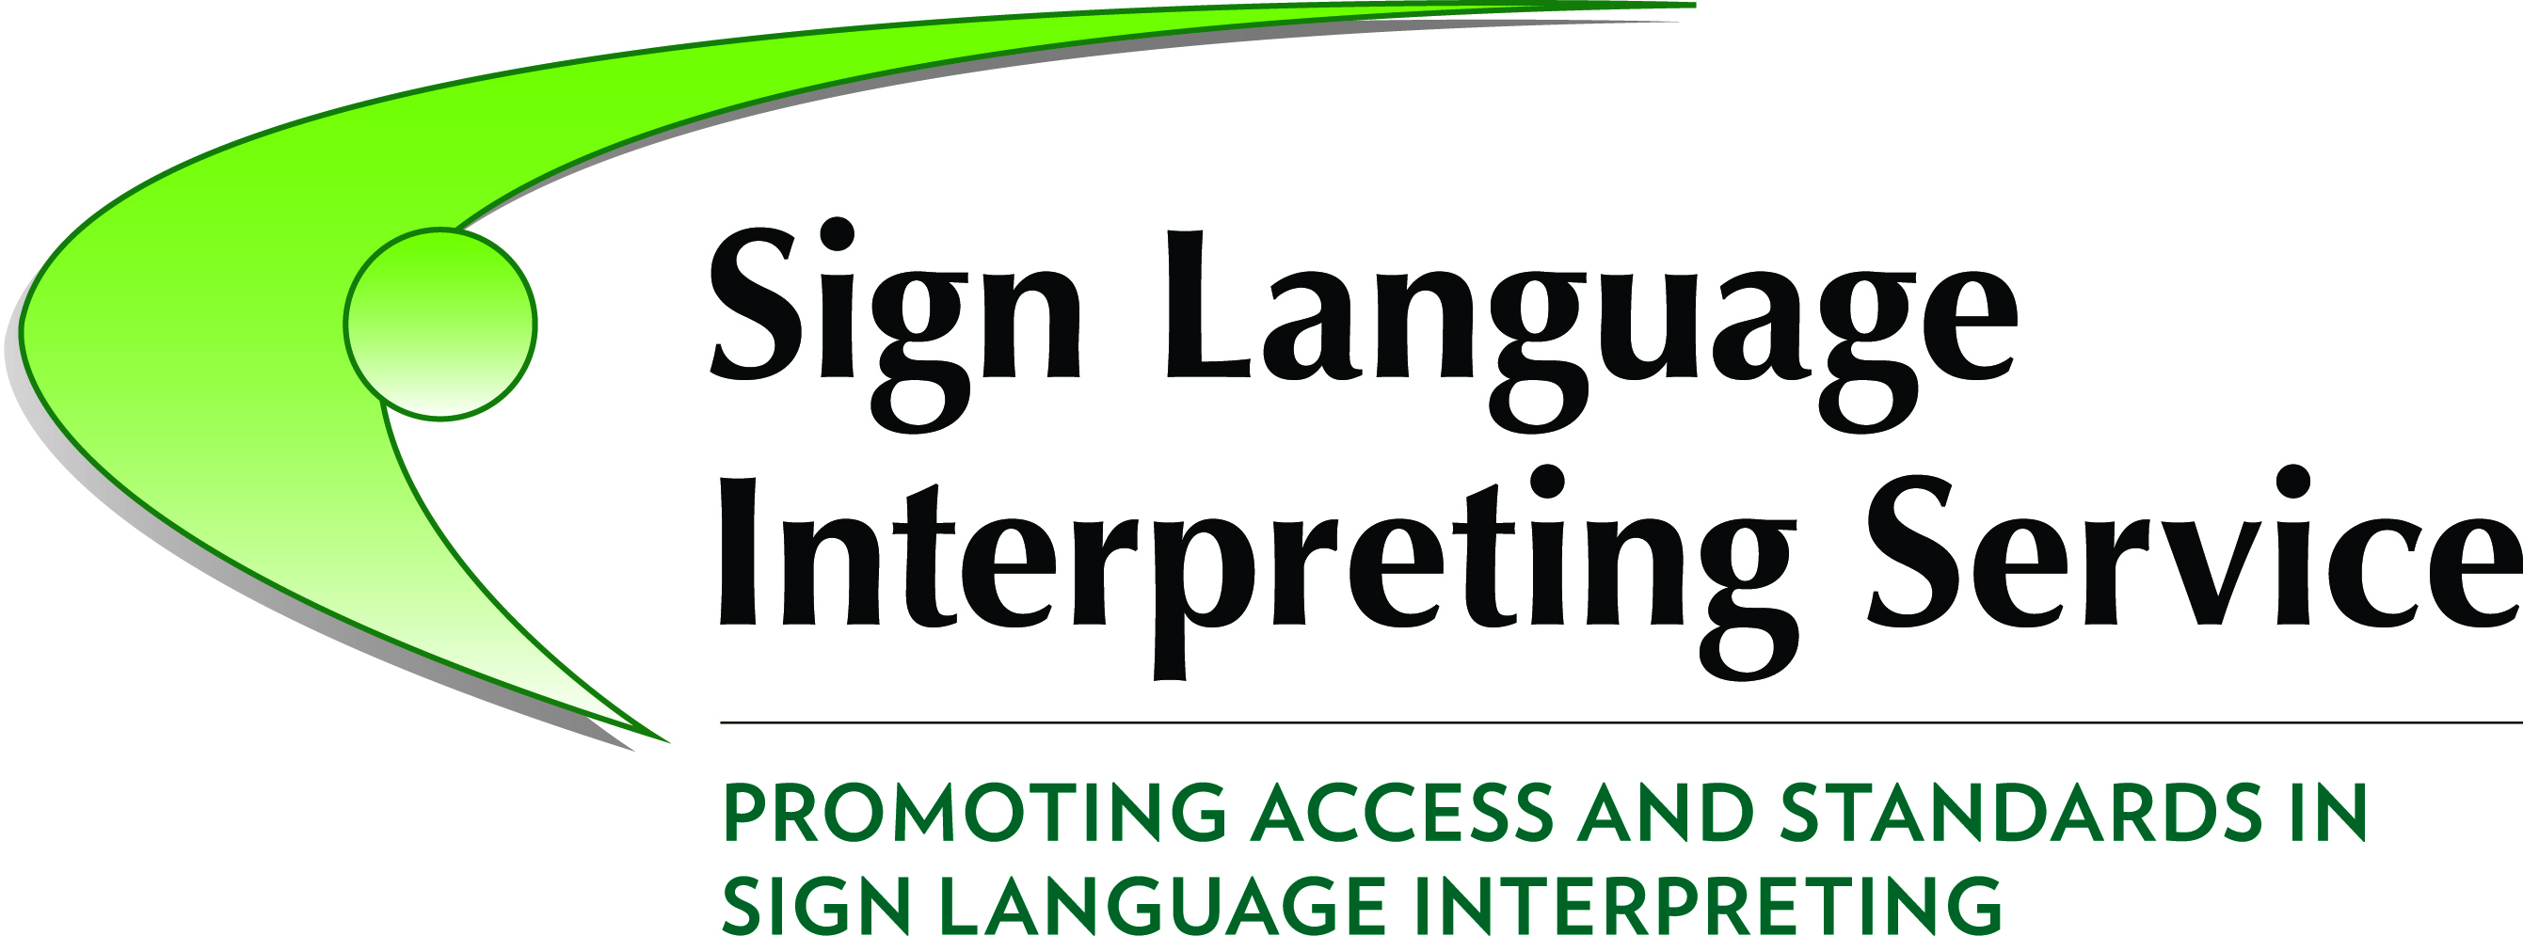 | 