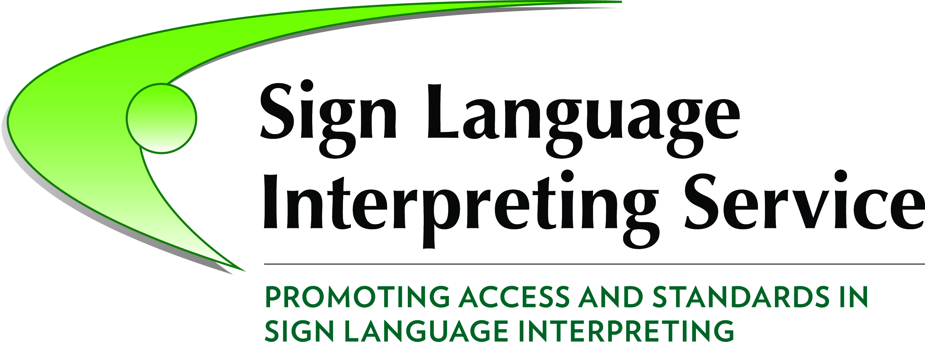
A national skill shortage in the availability of sign language interpreters

Sign Language Interpreting Service (SLIS) is supported by the Citizens Information Board (CIB) to develop interpreting services to Ireland’s Deaf community and service providers, particularly public services.
Summary
- 5,000 to 6,500 Deaf Irish Sign Language (ISL) users depend on ISL as their primary means of communication. Legislation to officially recognise ISL is passing through Oireachtas.
- Current capacity amounts to less than 12,000 sign language interpreting days per year.
- This is insufficient to meet the current demands of service providers and Deaf citizens, resulting in the “extreme marginalisation” of Ireland’s deaf community.
- New entrants to interpreting to 2019 will only maintain or marginally increase supply.
- Policy and legislative developments point to a step change in entitlements and demand for sign language interpreting, requiring many more interpreting days per year.
- There is a national skill shortage and a looming crisis necessitating urgent investigation and response by the state (i.e. the National Skills Council, the HEA and SOLAS).
- Building capacity in the sector is a win: win initiative. It can create employment, enhance economic and social inclusion of Deaf citizens and help meet 3 of the 6 objectives of Ireland’s National Skills Strategy 2025.

Context
There is growing recognition that the lack of availability of sign language interpreters is creating significant barriers to the provision of inclusive and equitable public services and to the participation of Deaf people in Irish society, despite national policies and current Equality and Disability legislation. This is reflected in three current policy developments.
- The Oireachtas identified “The experience of the Irish deaf community is one of extreme marginalisation due to the lack of sign language recognition and provision” and recommended legislative action to address this (October 2016).
- The Recognition of Irish Sign Language (ISL) for the Deaf Community Bill 2016, currently before the Oireachtas, proposes recognition of ISL and statutory entitlement to ISL interpreting, as well as regulation of sign language interpreters.
Link to the bill: http://www.oireachtas.ie/documents/bills28/bills/2016/7816/b7816s.pdf
- The National Disability Inclusion Strategy 2013-2015 commitments were not met, while the 2016-2018 strategy has specific objectives to expand the Irish Remote Interpreting Service (IRIS) and legislate for entitlement of Deaf people to public services.

Current supply of sign language interpreters
SLIS estimate current availability amounts to less than 12,000 sign language interpreter days per year. While 111 sign language interpreters have been trained from 1992 to present, SLIS estimate there are 75 sign language interpreters currently working in Ireland. Research indicates that less than half of current interpreters are full time (44%), with 22% working less than 1 day per week on average. Trinity College Dublin trains interpreters and states “The Centre for Deaf Studies has no doubt that there is a skills shortage…with the cycle of demand significantly outstripping supply”.
Current Demand
While there has been little investment in research, supply is clearly inadequate to meet the current demands of public and other service providers and those of the Deaf community.
- The Dáil (10 Nov 2016) unanimously recognised “extreme marginalisation due to the lack of sign language provision” and recommended legislation.
- The Citizens Information Board is completing research on the information needs of Deaf Citizens and the provision of services, and will be published in 2017. The draft final report finds “The shortage of trained ISL interpreters has been and remains one of the key obstacles to the achievement of the Deaf Community’s right to equal access to information and public services.” The final report recommends an urgent review of the supply ISL interpreters is carried out by the state.
“Given the urgency of the situation and the lead time to train sign language interpreters, policy-makers…should give immediate priority to developing measures to increase the supply of interpreters.”
- In 2016, SLIS received 1,355 requests for support in finding suitable interpreters – a 10% increase on 2015, and the highest numbers recorded since 2011. SLIS were able to match interpreters to jobs in less than half of all requests. Lack of interpreters is a major factor in not meeting requests from the Deaf community and service providers.
- The demand for the Irish Remote Interpreting Service exceeds current capacity.
- The Irish Deaf Society identified the severe shortage of sign language interpreters and the impact on social and economic inclusion of Deaf people and their employment.
Future Demand
While demand is increasing as Deaf people become more assertive about their existing rights and entitlements, current policy developments point to an imminent step change in entitlements of Deaf ISL users to, and the demand for, sign language interpreting.

The Recognition of Irish Sign Language (ISL) for the Deaf Community Bill 2016 has provisions for the state to provide a set number of hours interpreting and for statutory entitlements to interpreting and access to all public services. SLIS estimate that this would require about 215 additional sign language interpreters to meet the current draft provisions in the Bill in full (Table 2). The National Disability Inclusion Strategy 2016-2018 proposes legislation to provide entitlement to sign language interpreting for all public services, adding to demand.
Future Supply
The training and qualification pathway into the profession is too narrow. There will be an estimated 4 new entrants to interpreter practice per year until 2018. This will marginally increase capacity or merely replace those leaving the field. The use of new technology to provide online sign language interpreting is cost effective, efficient and can contribute to meeting increased demand in some circumstances (See IRIS example below).

What is needed?
In effect, supply will remain relatively static but a surge in demand is expected, rising to a crisis level if left unaddressed. An analysis of capacity and emerging demand in sign language interpreting is urgently required, to include recommendations for providing relevant skills development opportunities and the supply of skills to the labour market, as well as for active inclusion. (These come under 3 of the 6 objectives of Ireland’s National Skills Strategy 2025). This is best undertaken by the Expert Group on Future Skill Needs, or by the National Skills Council, in their roles of forecasting and prioritising skill needs.
SLIS recommend that initial training should be expanded, with higher or further education and training supports developed for those already in the profession. Potential solutions are :
- Increase the number of graduates coming through the TCD CDS degree programme.
- Recognition of Prior and Experiential Learning access to the TCD degree programme.
- Develop a blended learning programme to facilitate access to those outside Dublin.
- Develop Level 9 accredited training addressing legal and medical contexts.
- Support enhanced productivity from current interpreters, including greater use of technology, CPD and a programme to attract back those who have left the field.
The Department of Education and Skills, the Higher Education Authority and SOLAS are the responsible agents for policy, planning and funding of initial and continuing training, and should address this critical skills shortage.
Building capacity in the sector is a win: win proposition on economic, social and equity grounds. It can create employment (at least 100 jobs), enhance economic and social inclusion of Deaf citizens and help meet policy and public service commitments.

For Further Information Contact: John Stewart, Phone 087 650 6651 Email: john.stewart@slis.ie
1st February 2017. Updated 27 February 2017
Supporting Notes
About the Irish Remote Interpreting Service (IRIS)
- IRIS provides an online video link to a sign language interpreter using programmes such as Skype, Microsoft Lyncs (also called Skype for Business), Adobe Connect or WebEx.
- The IRIS interpreter joins a meeting by video link and translates between ISL and spoken English for the participants.
- Advance booking of the IRIS interpreters by email or text ensures availability and access.
- The service is operated by SLIS with funds provided by the Citizens Information Board.
- While IRIS is currently operating at 100% capacity, it could be scaled up to meet demand, for example as a basis for access to all public services.
- An evaluation of the service (2016) found it to be an effective and scalable service.
- A video in Irish Sign Language with subtitles and audio in English shows IRIS works. https://www.youtube.com/IRISvideo

A note on Training
The Centre for Deaf Studies (CDS) in Trinity College Dublin provides a bachelor degree in Deaf Studies and has been the main pathway for qualified ISL/English interpreters in Ireland. The Deaf Studies course is 4 years in length and is a level 8 qualification (honours degree).
The CDS previously ran a 2 years full-time Diploma course in Irish Sign Language/English Interpreting and produced 60 graduates from 2003-10. Since 2010, the Bachelor in Deaf Studies (Irish Sign Language/English Interpreting) course has produced 23 graduates (including some Diploma graduates who continued their studies to honours degree level.) This is the highest quality training available in the country and is projected to provide produces 4 interpreters per year to 2019, with other graduates working in associated sectors.
- https://www.tcd.ie/slscs/undergraduate/deaf-studies-bachelor/
The other current training course is the Signature NVQ Level 6 awards in sign language Interpreting and ISL. In 2016, there were 4 graduates of this course who joined the interpreting ranks.
- Signature Level 6 NVQ Diploma in Sign Language Interpreting (ISL language) AND
Signature Level 6 NVQ Certificate in Irish Sign Language (Level 8 equivalent)
SLIS recommend
  - A more accessible pathway into the interpreting profession to include wider options such as increasing the number of interpreters getting TCD CDS degrees, a blended learning programme with access for students outside Dublin, the use of RPEL to support entry from the community, and other courses such as a conversion course.
  - Continuing supports for those in the profession e.g. CPD and Masters level modules.
  - A programme to increase productivity from current stock of Interpreters and to attract back those who were trained but have left the profession.

A note on Productivity
Research indicates that interpreters currently work an average of 3.5 days per week per year, as many work in other part time jobs for various reasons. There is potential to increase capacity from the current stock of interpreters, although the returns are relatively small in the context of the expansion proposed by the ISL Recognition Bill. For example, if all interpreters increased productivity to 4.5 days per week, this would result in an additional 3,600 hours per year, (about another 2.5 full time equivalent interpreters).
Use of new technology to provide online remote Sign Language interpreting is cost effective, efficient and eliminates travel requirements thereby increasing interpreter time on task. Remote interpreting services can contribute to enhanced availability of interpreting. This may be particularly attractive to public services in light of emerging demand and legislation.

A Note on SLIS

Sign Language Interpreting Service (SLIS) is the national Sign Language Interpreting Service for Ireland, established in 2007 through the Citizens Information Board, following a review of sign language services in Ireland.
The mission of SLIS is to promote, represent, advocate and ensure the availability of quality interpretation services to Deaf people in Ireland. Our goal is to ensure that Deaf people can participate as full and equal citizens in Irish society with easy access to interpreting for relevant public and social services and are able to exercise their rights and entitlements, including under the Equal Status & Disability Acts. To this end, SLIS is supported by the Citizens Information Board (CIB).

Sign Language Interpreting Service, Deaf Village Ireland, Ratoath Road, Cabra, Dublin 7.

The Houses of the Oireachtas Joint Committee on Justice and Equality Report on the Formal Recognition of Irish Sign Language, Government Publications: October 2016.
Leeson, L. and Venturi, L. (in press). A Review of Literature and International Practice on National and Voluntary Registers for Sign Language Interpreters. Dublin: Sign Language Interpreting Service.
Leonard C., ISL / English Interpreter Income Survey Report, CISLI November 2016
Centre for Deaf Studies paper 2017 to Department of Education and Skills (16 February 2017)
Information provision and access to public and social services for the Deaf Community, (Citizens Information Board 2017, unpublished)
Clarke, A., Evaluation of IRIS- the Irish Remote Interpreting Service, SLIS, June 2016
Irish Deaf Society, Working Paper on the ISL recognition Dr. John Bosco Conama and Carmel Grehan, 2012.
Ireland’s National Skills Strategy 2025, Pathways to work 2016 – 2020, and the Action Plan for Jobs.
Clarke, A., Evaluation of IRIS- the Irish Remote Interpreting Service, SLIS, June 2016

